TECHNICAL REPORT ON STUDENT INDUSTRIAL WORK EXPERIENCE SCHEME (SIWES)

AT
PHYSICAL PLANNING, FEDERAL POLYTECHNIC,
MUBI, ADAMAWA STATE

FROM: 6TH OCTOBER, 2024
TO: 29TH JANUARY, 2025

TITLE PAGE

BY
HAYATUDEEN MUHAMMED MEDUGU
(SE/ARC/ND/23/011)

SUBMITTED TO THE DEPARTMENT OF ARCHITECTURAL TECHNOLOGY, FEDERAL POLYTECHNIC MUBI, IN PARTIAL FULFILLMENT OF THE REQUIREMENT FOR THE AWARD OF NATIONAL DIPLOMA (ND) IN ARCHITECTURAL TECHNOLOGY

MAY, 2025

DECLARATION
This is to declare that I, HAYATUDEEN MUHAMMED MEDUGU with registration number SE/ARC/ND/23/011 undertook my four months SIWES at PHYSICAL PLANNING, FEDERAL POLYTECHNIC, MUBI, ADAMAWA STATE and have acquired all the experience compiled in this report in the course of my SIWES.

……………………………….. ……………………………
HAYATUDEEN MUHAMMED MEDUGU Sign/Date

CERTIFICATION
This is to certify that this report compiled by HAYATUDEEN MUHAMMED MEDUGU (SE/ARC/ND/23/011) meets the requirement of governing the award of National Diploma (ND) of the Federal Polytechnic Mubi, and is approved by:

………………………………. ……………………
Name of Supervisor Date
Departmental Supervisor

………………………………. ……………………
Arc. Daniel Barka Date
Departmental SIWES Coordinator

…………………………………. ……………………
Arc. Mohammed Usman Date
Head of Department

DEDICATION
I dedicate this technical report to my parents, my sisters and colleagues and to all those that supported me throughout the industrial training.

ACKNOWLEDGEMENTS
First of all, my sincere appreciation goes to Almighty God for his guidance and protection throughout my industrial training.
I wish to thank all staff of Architectural Technology department in Federal Polytechnic, Mubi.
My appreciation goes to my beloved parent for the motivation, prayers and financial support towards my SIWES exercise.
My special thanks go to my beloved brothers and sisters for all their care and support throughout my industrial training.
I want to also thank my colleagues and others; I really appreciate your efforts.

TABLE OF CONTENTS
TITLE PAGE i
DECLARATION ii
CERTIFICATION iii
DEDICATION iv
ACKNOWLEDGEMENTS v
TABLE OF CONTENTS vi
ABSTRACT vii
CHAPTER ONE 1
1.0 INTRODUCTION 1
1.1 Aim and objective of SIWES 1
1.2 Brief history of SIWES and ITF in Nigeria 2
1.3 Significance of SIWES to students 2
CHAPTER TWO 4
2.1 BRIEF HISTORY OF PHYSICAL PLANNING, FEDERAL POLYTECHNIC, MUBI, ADAMAWA STATE 4
2.2 COMPANY ORGANOGRAM 5
CHAPTER THREE 6
3.0 DESCRIPTION OF WORK EXPERIENCE 6
3.1 BLOCK WORK 6
3.2 CASTING 7
3.3 SETTING OF PILLARS AND COLUMN BASE 9
3.5 IRON WORK (WIRE MESH) 12
3.6 SAND FILLING AND WATERING 13
CHAPTER FOUR 15
4.0 SUMMARY, CONCLUSION AND RECOMMENDATIONS 15
4.1 PROBLEMS OBSERVED DURING MY PROGRAM 15
4.2 SUMMARY 15
4.3 CONCLUSION 16
4.4 RECOMMENDATIONS 16
REFERENCES 17

ABSTRACT
The report summarises the result of work done during my SIWES experience, the technical report consists of four chapters, which comprises of introduction, history and criteria’s of SIWES in chapter one followed by their aims and objectives, historical background, organizational structure of the organization in chapter two, while chapter three consist of the work actually carried out during the SIWES programme and lastly chapter four consist of the summary, conclusions and recommendation.

CHAPTER ONE

1.0 INTRODUCTION
The acronym (SIWES) meaning “Student Industrial Work Experience Scheme” is a skill training designed to expose and prepare student in institution of higher for industrial working situation they may likely meet after graduation. The scheme is meant to train student on the method of work and the experience needed in handling the equipment and machines may not to be available in their institution. The scheme is financed by the Federal Government and operators through Industrial Training Fund (ITF), Ogwo, (2001) and operates with National University Commission (NUC), National Board of Technical Education (NBTE), and National Commission for College of Education (NCCE) and industries. However, SIWES also expose the student to many practical works which the institution did not treat in details without plastering what the institution taught theoretically into practical. A point from academic obtained. SIWES assist the student to understand the nature of his/her work in future.

1.1 Aim and objective of SIWES
ITF initiates SIWES with the sole aim of: Exposing student with the practical experience related to the theoretical knowledge acquired in school. Bridging the gap between theoretical learning and practical work situation.
- To make industries/organization to have confidence in the abilities and capacities of the graduates. SIWES helps the industries to evaluate the prospective employees and give feedback to the institution.
- It helps the student to gain work and also have experience and confidence as a result if successful completion of a given job assigned to them.
- To enlist and strengthen the employers’ involvement in the institution activities and in the entire educational process of preparing the student for meaningful and productive employment into industries.
- It provides an avenue for student in the Nigerian University and Polytechnics to acquire industrial skill and experience in their course of study.
- Development for greater understanding in other people and proffers skills in human relations.

1.2 Brief history of SIWES and ITF in Nigeria
It was said by Dr. Azikiwe Nnamdi, the one president of Nigeria that the practice of work but they all have the same goal that they all want to achieve in countries like china. They established within the premises of institution to provide real life situation, lack of practical skill of locally trained engineers and technologies. the chine way and condition of SIWES is that all institution must give student real life working experience in industrial works. Lecturers are involved in the industrial activities rendering constant services. So, all these countries have their own way of conducting the scheme but all lye on the same goal. And in Nigeria, the history of SIWES can be traced by the history of IITF which is the backbone of SIWES. ITF was established in 1974 under degree of 47 of 1971. It was a body established by the Federal Government of Nigeria and was given responsibility of training indigenous Nigerians. The establishment of the body became necessary due to high demand of Nigeria to take up the vacant positions created in various sector of the economy after the colonial masters have departed. Therefore, the Federal Government discovered that it is easier to train students that are skilled in school to be trained and meet up with gaps in the Nigerian economy and a scheme was established to care for such training and it was named Student Industrial Work Experience Scheme (SIWES). In 1973, the national board of technical education (NBTE) made it compulsory for all the polytechnic students, be it federal or state.

1.3 Significance of SIWES to students
Principles taught in the classroom are vein forced given concrete applications on the industrial assignment and students is able to see the relevance of their students which increase their motivation. It helps in given students the knowledge on the types of work to do after his/her graduation. SIWES given students opportunity for a change of environment as they move their institution to the place of attachment which changes the routine types of environment to a word of work. It helps in connecting the institution and the industrial their relationship the introduction of SIWES.

CHAPTER TWO

2.1 BRIEF HISTORY OF PHYSICAL PLANNING, FEDERAL POLYTECHNIC, MUBI, ADAMAWA STATE
The Physical Planning Directorate, Federal Polytechnic, Mubi, Adamawa State, was established in the year 2009, with the sole aim of planning, design, construction and supervision of new project in the Federal Polytechnic, Mubi be it in contract or direct labour. And procurement and preparation of land document.
The following are some units in the Physical Planning Directorate, Federal Polytechnic, Mubi;
Architecture: Responsible for design and supervision of construction works in the Polytechnic.
Civil Engineering: Responsible for the supervision of construction of structural element during construction.
Building Tech: Responsible for supervision and quality control.
Town planning: Planning and maintaining the layout plan of the polytechnic.
Quantity surveyor: Participates in tendering, preparation of contract document, valuation etc.
Craft men: Assist the professional in carrying out their duties
Admin: The Administrative staff supports all the staff in the directorate.

2.2 COMPANY ORGANOGRAM
DIRECTOR OF WORKS
TOWN PLANNERS
PRINCIPAL TOWN PLANNERS
ARCHITECTS
ADMIN
ENGINEERS
ASST. CHIEF TECH OFFICER
CHIEF ARCHITECT
BUILDING ENGINEER
CIVIL ENGINEER
PRINCIPAL BUILDING ENGR..
ASST. CHIEF TECH OFFICER

FOREMAN
FINANCIAL TECHNICIAN
PRINCIPAL TOWN PLANNERS
ASST. CHIEF TECH OFFICER

PRINCIPAL EXECUTIVE OFFICER
HIGHER EXECUTIVE OFFICER

CONFIDENTIAL SECRETARY
CLERK
LAB ATTENDANT

Figure 2.1: Organogram

CHAPTER THREE

3.0 DESCRIPTION OF WORK EXPERIENCE

3.1 BLOCK WORK
Blocks were molded in a number of sizes, various compositions, strengths, and shapes such as 9 inches. The 9-inch blocks were used for external walls, while the 6-inch ones were for internal walls. After the foundation work was finished, the blockwork was built to cover the spaces as well. All the blockwork did not carry any load; they were erected to cover spaces and also act as partition walls.
Procedure
- Before starting the block laying process, the site was prepared by clearing debris and ensuring a level foundation.
- The layout of the walls or structure was marked using chalk lines or strings to guide the placement of the blocks.
- Blocks or bricks were selected based on the desired strength, size, and aesthetic requirements of the project.
- Mortar was mixed according to the specifications, typically using a combination of cement, sand, and water.
- A layer of mortar was spread evenly along the foundation where the first course of blocks would be placed.
- A level was used to check the horizontal and vertical alignment of the blocks.
- Once the first course was laid, additional courses of blocks were added on top, following the same process.
- Each block was buttered with mortar on its ends before being placed to ensure a strong bond between the blocks.
- Blocks may have needed to be cut to fit around corners, openings for doors or windows, or to maintain the desired pattern.
- Excess mortar was scraped off the joints using a trowel, and any gaps or voids were filled to create a smooth, uniform surface.
- Once the block laying was complete, the work area was cleaned up, and any excess materials or debris were removed from the site.
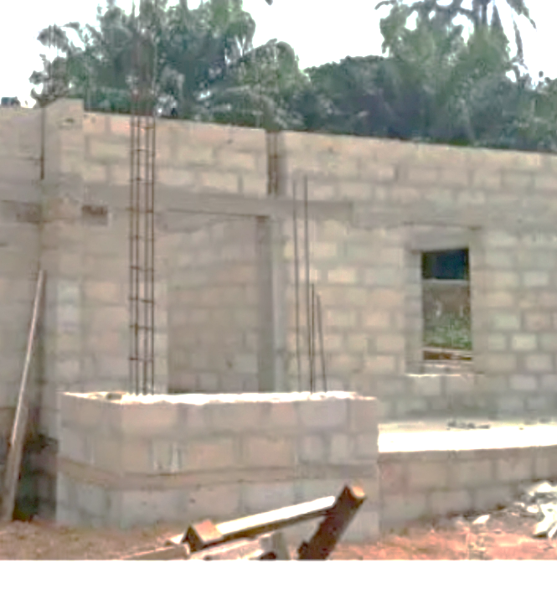
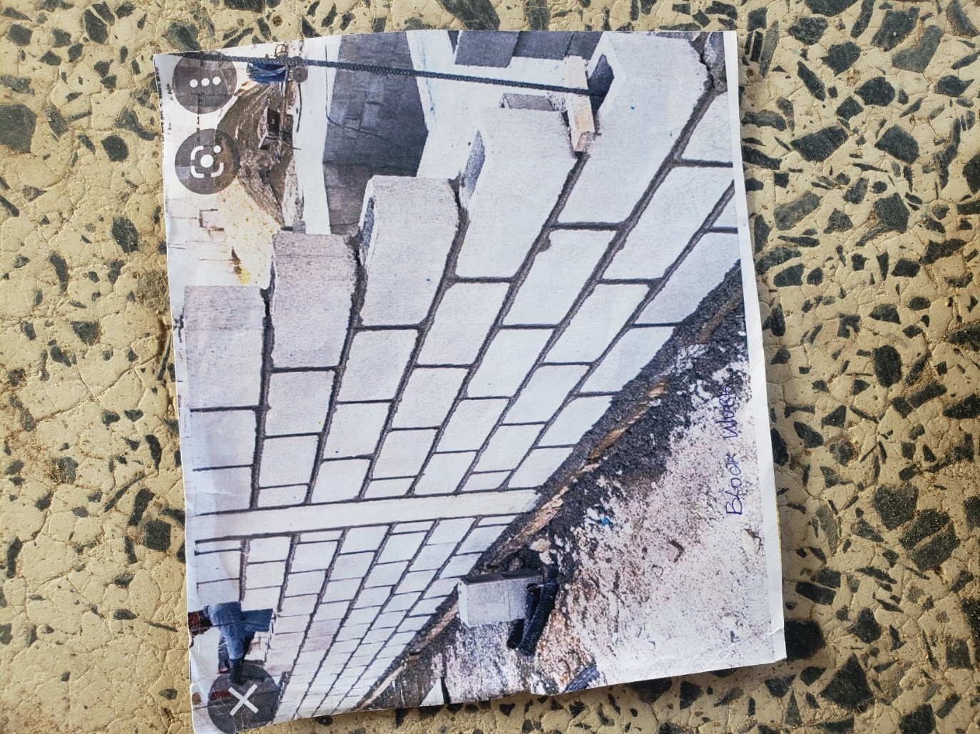
Plate 3.1: Block work

3.2 CASTING
Casting is a fundamental process in construction, involving the pouring of concrete into molds or formwork to create various structural elements. This section involves the casting procedures carried out for down beams, lintels, upper beams, and floors.
3.2.1 Casting of down beam
- Formwork was prepared and set up according to specifications.
- Reinforcement was placed within the formwork.
- Concrete was poured into the mold and vibrated for compaction.
- The cast down beam was left to cure before the formwork was removed.
- Any surface imperfections were addressed through finishing techniques.
3.2.2 Casting of Lintel
- Formwork was erected, and reinforcement was installed.
- Concrete was poured into the formwork and compacted.
- After curing, the formwork was stripped, revealing the cast lintel.
- Finishing touches were applied to achieve the desired appearance and dimensions.
3.2.3 Casting of Upper Beam
- Formwork was prepared, and reinforcement was placed.
- Concrete was poured into the formwork and compacted.
- The cast upper beam was allowed to cure before the formwork was removed.
- Finishing techniques were employed to address any surface imperfections.
3.2.4 Casting of Floor
- The subbase was prepared, and formwork was installed around the perimeter.
- Reinforcement was placed within the formwork.
- Concrete was poured onto the prepared subbase and leveled.
- After curing, the formwork was removed, revealing the finished floor surface.
- Surface protection measures were implemented to safeguard the newly cast floor.
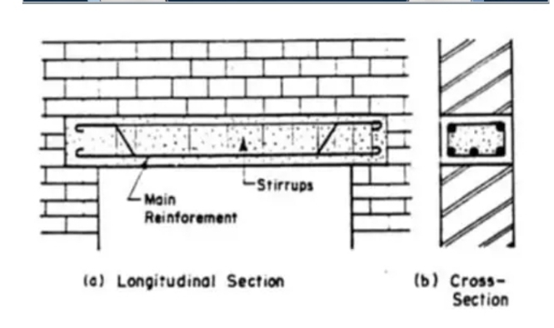
Plate 3.2: Casting of lintel

3.3 SETTING OF PILLARS AND COLUMN BASE
We usually tie a rope to out or in-to-in and then place our pillar in the middle of the block to make it align and in straight line.
After putting the baskets in their respective positions, the pillars are then set with the ropes (crossed in between the ropes). Then we made sure that the pillar is not touching the rope, and then tied it to the basket with the blinding wear, stroke in the middle of the pillar with braces so that to hold it in position and in line. After that concrete mix is then applied to fill in the 1 feet depth carefully without tempering with the position of the pillar and then being rammed.
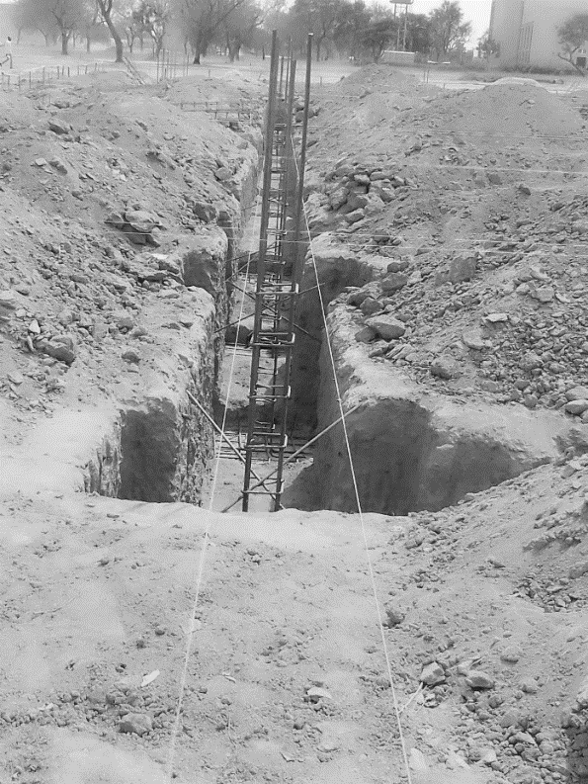
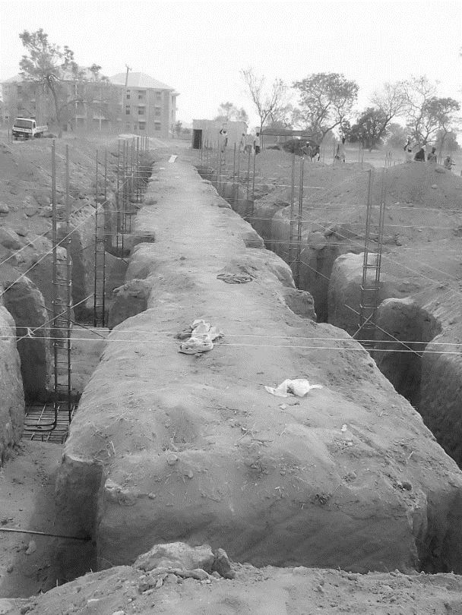
Plate 3.3: Blinding

3.4 PLASTERING OF WALL
Plaster is a thin layer of mortar applied over the masonry surface and it acts as a damp-proof coat over the masonry work. Plastering also provides a finished surface over the masonry that is firm and smooth hence it enhances the appearance of the building.
Tools for plastering
- Plastering trowel - choose a stainless-steel trowel with a comfortable, evenly weighted handle.
- A plasterer’s hawk board - this is the tool that holds your plaster. A plastic hawk board is lighter than a wooden one, although both types are absolutely fine. A wooden hawk board will last much longer though.
- Bucket trowel - this tool is specially designed to make it easy to scoop plaster from the bucket to your hawk board.
- A power mixer - although it’s fine to mix the plaster by hand, using a power mixer is much easier and quicker. It’s especially suitable if you’re creating large batches of plaster which need to be applied quickly.
- A good quality paint brush - this is essential for keeping your edges clean and applying water to your plaster.
Procedure
- Prepared the Wall: Ensured the wall surface was clean, dry, and free from dust, dirt, and loose debris. Repaired any cracks or defects in the wall by filling them with patching compound or plaster.
- Prepared the Plaster Mix: Mixed the plaster by combining the appropriate ratio of cement and sand in a clean bucket.
- Wetted the Wall: Dampened the wall with water using a brush or spray bottle to prevent it from absorbing water from the plaster too quickly.
- Applied the First Coat (Scratch Coat): Loaded the plaster mix onto a plastering hawk.
- Allowed it to Set: Let the scratch coat set for a while until it became firm but not completely dry.
- Applied the Final Coat (Finish Coat): Once the brown coat was partially set but still damp, applied the final layer of plaster (finish coat) using a plastering trowel.
- Smoothed the surface to achieve the desired finish.
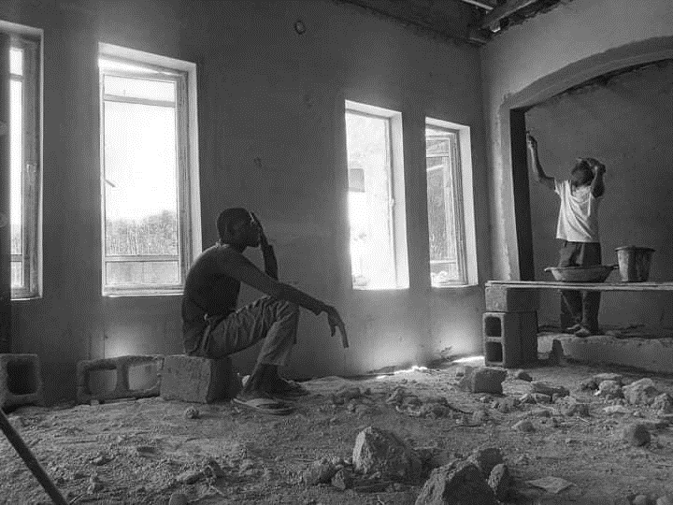
- Finished and Cleaned Up: Neatly trimmed corners and edges using a trowel or corner beads if necessary. Cleaned tools and equipment immediately after use to prevent plaster from hardening on them.

Plate 3.5: Mixed mortar and the plastering process

3.5 IRON WORK (WIRE MESH)
As part of the reinforcement preparation for the next phase of construction on the new residential building, we undertook the task of bending wire mesh, commonly referred to as the "bending of basket." This step is crucial in forming the reinforcement cages used in structural elements such as columns, beams, slabs, and staircases. The wire mesh baskets provide the necessary tensile strength to the concrete and help control cracking due to shrinkage or stress.
We began by reviewing the structural drawings to determine the required dimensions, shape, and spacing of the wire mesh. The reinforcement bars (usually high-yield steel rods of 8mm, 10mm, or 12mm diameter) were measured and cut to length using a steel cutter. The bending process was carried out manually using a bending machine or steel pipe levers, depending on the thickness of the rods and the required angles.
Skilled iron benders then carefully bent the rods into the desired shapes—typically rectangular or square cages—ensuring precision and uniformity across all units. These bent rods were tied together using binding wire to form the complete basket or cage. During assembly, special attention was given to maintaining accurate spacing between the rods and ensuring all corners and joints were properly secured to prevent displacement during concrete placement.
Once completed, the baskets were stored carefully on flat, dry ground or suspended above the floor to prevent rusting and deformation before installation. These reinforcement cages were later placed into formworks for columns, beams, or slabs, in line with structural specifications. The bending of wire mesh baskets marked a key preparatory stage in reinforcement work, helping to ensure the structural integrity and longevity of the reinforced concrete elements in the building.
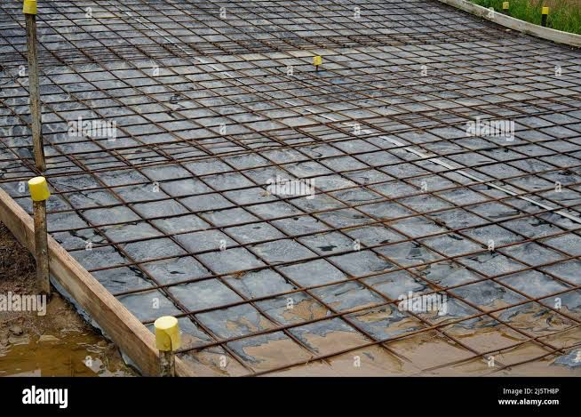
Plate 3.6: Wire Mesh

3.6 SAND FILLING AND WATERING
After the excavation and reinforcement works were completed, I took part in the process of filling the foundation with sand. This step was essential to provide a firm base and to support the foundation structure. We used sharp, clean sand to fill the gaps around the reinforcement and within the excavated trenches. The sand was poured in layers, and after each layer, we compacted it manually using rammers to reduce air pockets and ensure proper settlement. Once the filling was done, we proceeded to water the sand thoroughly. This watering process helped to increase compaction and stabilize the soil, reducing the chances of future settlement or foundation cracks.
I noticed that watering the sand also helped in binding the particles together, making the filled foundation trench more solid. The site supervisor emphasized that this step was important in achieving long-term structural stability. Overall, the combined process of sand filling and watering played a key role in preparing the foundation for concrete work and ultimately contributed to the durability of the entire building.
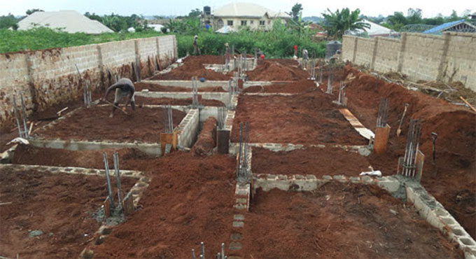
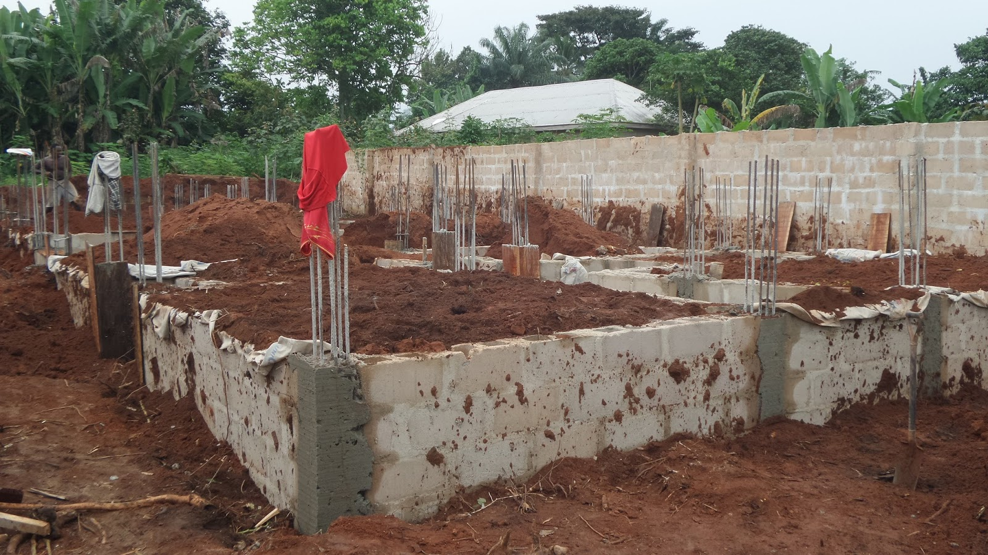
Plate 3.7: Sand feeling and watering

CHAPTER FOUR

4.0 SUMMARY, CONCLUSION AND RECOMMENDATIONS

4.1 PROBLEMS OBSERVED DURING MY PROGRAM
- The time frame set for the program is too short as some of the aspects of the program where not completed.
- Lack of Financial support from the company to aid transportation to and from training.
- Attentions are not given to the IT students by the workers it is learn if you want to learn or ask if you want to know.

4.2 SUMMARY
One would state that the discipline is the training of the mind and body towards effective performance. The Students Industrial Work Experience Scheme (SIWES) is more or less achieving this fit. As it further builds on the theoretical classrooms leaving a practical approach of the industry and commerce to supply of finished goods and services. This program has enabled the participating students to be practically involved in the day-by-day activities of the industries and commerce.
Emphasis in the observation of industrial safety rules and regulations, time critical operation and proper man-hand management, quality cortices, etc. are daily activity objective. All those aimed at the production of marketable goods and services in the world of work.
However, to consolidate on the gains of this Industrial Training Fund (ITF) higher institution coordinator on SIWES program should be allowed making some suggestion and recommendation.

4.3 CONCLUSION
SIWES programme is very vital student especially undergraduates, because I come to see the SIWES programme provide an application of the theoretical knowledge learned by student in school to practical or real work situation. Also, it is a medium where student from different higher institutions and department come together sharing idea there, by promoting an avenue for learning and them work.

4.4 RECOMMENDATIONS
Having being exposed to a bit of what entail working in an individual related to my course of study under SIWES programme I wish to make this recommendation
- Higher instruction of learning especially either institution and universities should establish link with comprise and establishment so as to provide space for student on industrial attachment, with the option of gaining employment in future, by doing so, it will go a long way in alleviating suffering and difficulties encountered by student in securing place for individual attachment.
- Student should put money as the primary aim of going SIWES programme, there is more to learn than Bain allowance.

REFERENCES
Chudley, R. (2005). Construction technology volume 2. Pearson Prentice Hall, New York.
Chudley, R., & Greeno, R. (2016). Building Construction Handbook (11th ed.). Routledge.
Edward, B. (2003). The Effect of SIWES on a student, Federal Ministry of Works, Lagos. Nigeria.
Emmitt, S., & Gorse, C. A. (2014). Barry’s Introduction to Construction of Buildings (3rd ed.). Wiley-Blackwell.
Francis, K. (2012). Building Construction Illustration. (Fourth Edition). Wiley Publisher. ISBN-10: ‎ 9788126535637.
Mamlouk, M. S., & Zaniewski, J. P. (2017). Materials for Civil and Construction Engineers (4th ed.). Pearson.
National Ready Mixed Concrete Association (NRMCA). (2003). Concrete in Practice – CIP 4: Placing Concrete.
Neville, A. M. (2011). Properties of Concrete (5th ed.). Pearson Education Limited.

